R analysis

Data analyst: Abraham Cedeño

Date: 10th October 2022

In this document, I will use R to answer the S.M.A.R.T questions I created when I started the data analysis.

**Data category 1 - Bike preferences**

**SMART Question one:** “What was the percentual distribution of bike preferences among casual and member riders in the last 12 months?”

**Answer:** I performed some calculations in R and obtained the following results.

**Bike preference for casual riders**

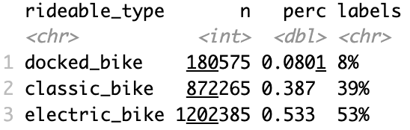

**Bike preference for member riders**

**Visualizations for SMART question #1**

**Data category 2 - Trips start day and time**

**SMART Question two:** “On which days of the week have our members used more often the services in the last 12 months?”

**Answer:** I performed some calculations in R and obtained the following results.

**Day trips per casual riders**

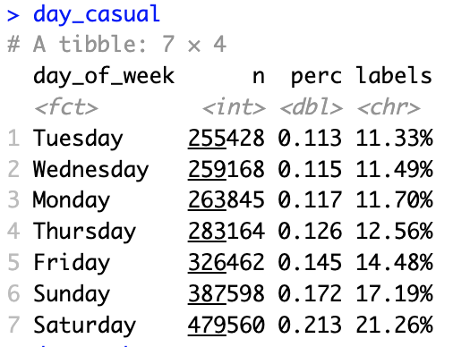

**Day trips per member riders**

**Visualizations for SMART question #2**

**SMART Question three:** “At which times of the day have our members used more often the services in the last 12 months?”

**Answer: I** performed some calculations in R and obtained the following results.

**Times with more trip counts for casual riders**

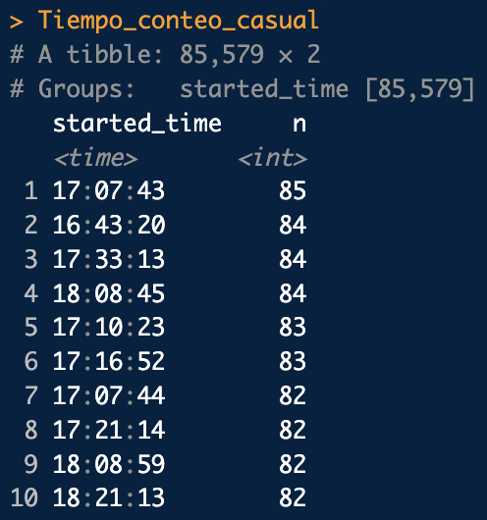

**Times with more trip counts for member riders**

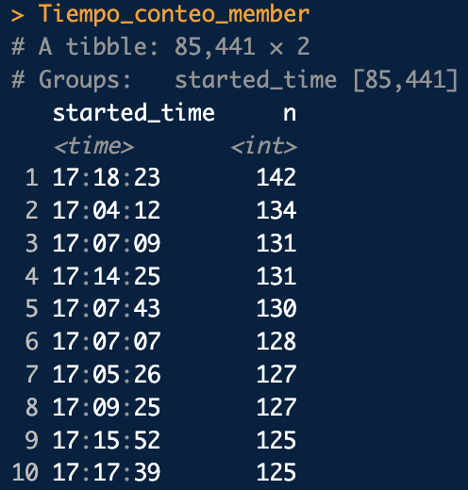

**Visualizations for SMART question #3**

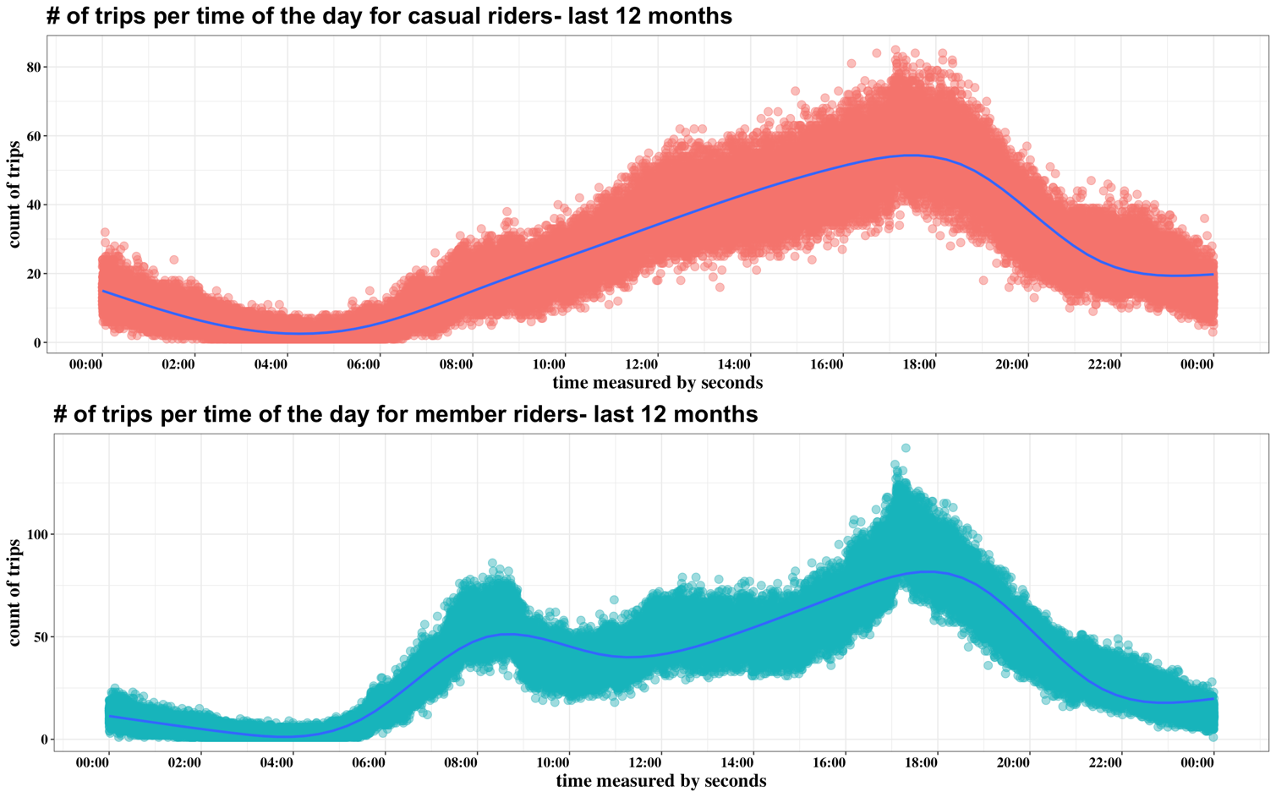

**Data category 3 - Trips end day and time**

**SMART Question four: “**What was the average trip duration of our members in the last 12 months?

**SMART Question five: “**What was the average trip duration of our casual riders in the last 12 months?”

**Answer:** I performed some calculations in R and obtained the following results.

**Mean of casual rider’s trip duration in date-time format**

**Mean of member rider’s trip duration in date-time format**

**Visualizations**

**Data category 4 – Start stations**

**SMART Question six:** “On which stations did the member riders start their rides more often in the last 12 months?”

**Answer:** I performed some calculations in R and obtained the following results. Also, since I made these visualizations when I was using SQL, I decided to not make them again in R.

**Top 10 start stations for casual riders**

**Top 10 start stations for member riders**

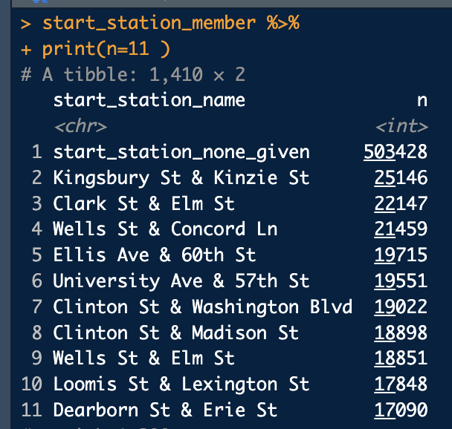

**Visualizations**

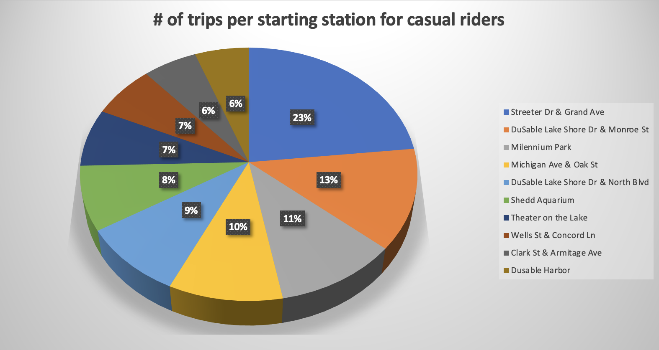

**Data category 5 – End stations**

**SMART Question seven:** “On which stations did the member riders finish their rides more often in the last 12 months?

**Answer:** I performed some calculations in R and obtained the following results. Also, since I made these visualizations when I was using SQL, I decided to not make them again in R.

**Top 10 end stations for casual riders**

**Top 10 end stations for member riders**

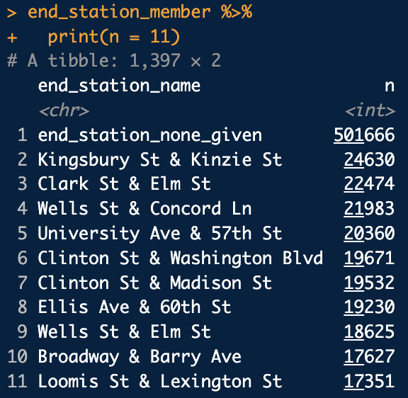

**Visualizations**

**Data category 6 – Start latitude and longitude**

**SMART Question eight:** “What was the distribution of rides starting point per longitude for both casual and member riders in the last 12 months?”

**SMART Question nine:** “What was the distribution of rides starting point per latitude for both casual and member riders in the last 12 months?”

**Answer:** I think I would be able to answer this question better with a visualization in tableau because I can plot the latitudes and longitudes in a map. Nevertheless, I still plot the histograms of latitude and longitude per trip.

**Data category 7 – End latitude and longitude**

**SMART Question ten:** “What was the distribution of rides ending point per longitude for both casual and member riders in the last 12 months?”

**SMART Question eleven: “**What was the distribution of rides ending point per latitude for both casual and member riders in the last 12 months?”

**Answer:** I think I would be able to answer this question better with a visualization in tableau because I can plot the latitudes and longitudes in a map. Nevertheless, I still plot the histograms of latitude and longitude per trip.

